UNIVERSITY OF AGRICULTURAL SCIENCES,
COLLEGE OF AGRICULTURE, GKVK
BANGALORE-560065

EAI421 - APPLICATION OF ARTIFICIAL INTELLIGENCE
AND MACHINE LEARNING
PROJECT TITLE:
Fertilizer Recommendation Based on Temperature, Rainfall,
Humidity, Soil Type, Crop Type and NPK
Submitted to:
Syed Muzamil Basha
Course Teacher, Application of AI & ML
COA, GKVK, Bangalore-65
Submitted by:
Sudhakara H S — AMB2270
Vasanth Kumar R S — AMB2290
Vinay O L — AMB2301
VI B.Sc. (Hons.) Agriculture
COA, GKVK, Bangalore-65

CERTIFICATE
This is to certify that the project entitled FERTILIZER RECOMMENDATION BASED ON TEMPERATURE, RAINFALL, HUMIDITY, SOIL TYPE, CROP TYPE AND NPK has been successfully carried out and submitted by Sudhakara H S (Reg. No: AMB2270), Vasanth Kumar R S (Reg. No: AMB2290) and Vinay O L (Reg. No: AMB2301) of VI B.Sc. (Hons.) Agriculture, College of Agriculture, GKVK, University of Agricultural Sciences, Bangalore-560065, in partial fulfilment of the requirements for the course EAI421 – Application of Artificial Intelligence and Machine Learning.
The project work is original and has not been submitted elsewhere for the award of any degree or diploma. The candidates have satisfactorily completed all prescribed requirements and the project report is approved.
Guide
Name: Syed Muzamil Basha
Designation: course teacher
Place :GKVK, Bangalore
Date: 15-04-2026

ACKNOWLEDGEMENT
We would like to express our heartfelt gratitude to all those who have contributed to the successful completion of this project. First and foremost, we extend our sincere thanks to our project guide and mentor for providing continuous guidance, valuable suggestions, and encouragement throughout the course of this work.

We are deeply grateful to the Head of the Department and the faculty members of our department for their constant support and for providing the necessary resources and infrastructure to carry out this project. Their constructive feedback and insightful comments have greatly enhanced the quality of this work.

We would also like to thank our institution for creating an environment that fosters research, innovation, and learning. A special note of thanks goes to Kaggle and the open-source community for making the Fertilizer Recommendation Dataset publicly available. We also acknowledge the developers and contributors of Python, Scikit-learn, Pandas, NumPy, and Matplotlib for providing robust open-source tools.

Finally, we are grateful to our friends and family for their unwavering moral support, patience, and encouragement throughout the academic journey.

Sudhakara H S (AMB2270)
Vasanth Kumar R S (AMB2290)
Vinay O L ( AMB2301)

ABSTRACT
Agriculture is the backbone of economies across the world, and the precise application of fertilizers is critical to maximizing crop yield while minimizing environmental degradation. This project presents a machine learning-based Fertilizer Recommendation System that intelligently predicts the most suitable fertilizer for a given crop and soil condition based on multiple environmental and agrochemical parameters.

The system utilizes a real-world dataset containing features such as Temperature, Humidity, Soil Moisture, Soil Type, Crop Type, Nitrogen, Phosphorus, and Potassium levels. Four supervised classification algorithms were evaluated: Decision Tree Classifier, Random Forest Classifier, Logistic Regression, and Artificial Neural Network (ANN). Each model was trained on pre-processed data involving label encoding of categorical variables and standardization using StandardScaler.

Results demonstrate that the original Decision Tree Classifier achieved the highest test accuracy of 92.11%, followed by a Tuned Decision Tree (89.47%), Random Forest (86.84%), Logistic Regression (71.05%), and ANN (65.79%). Hyperparameter tuning using GridSearchCV further validated the Decision Tree with a cross-validation accuracy of 98.20%. The system serves as a practical tool for precision agriculture, enabling data-driven fertilizer decisions that can enhance crop productivity and reduce wasteful resource usage.

Keywords: Fertilizer Recommendation, Machine Learning, Decision Tree, Random Forest, Logistic Regression, ANN, Precision Agriculture, Classification.

TABLE OF CONTENTS
# | Chapter / Section | Page
— | Certificate | ii
— | Acknowledgement | iii
— | Abstract | iv
— | Table of Contents | v
— | List of Figures | vi
— | List of Tables | vii
1 | Introduction | 1
2 | Objective | 3
3 | Literature Review | 4
4 | Problem Statement | 8
5 | Dataset Description | 9
6 | Methodology | 10
7 | Data Processing and Feature Scaling | 11
8 | Algorithms Used | 13
9 | Results and Model Evaluation | 15
10 | Visualization | 18
11 | Limitations | 20
12 | Conclusion | 21
— | References | 22

LIST OF FIGURES
Figure No. | Figure Title | Page
Figure 1.1 | Fertilizer Recommendation System — Conceptual Overview | 1
Figure 6.1 | System Methodology Flowchart | 10
Figure 9.1 | Overall Model Accuracy Comparison Bar Chart | 16
Figure 9.2 | Precision and Recall Comparison Across All Models | 17
Figure 10.1 | Decision Tree Visualization — Tuned Model | 18
Figure 10.2 | Confusion Matrix — Decision Tree (Original) | 19

LIST OF TABLES
Table No. | Table Title | Page
Table 3.1 | Literature Review Summary | 7
Table 5.1 | Dataset Feature Description | 9
Table 5.2 | Label Encoding Mappings for Categorical Features | 9
Table 7.1 | Feature Scaling Details — StandardScaler Applied to All Input Features | 12
Table 8.1 | Algorithms Used — Key Parameters and Descriptions | 13
Table 9.1 | Accuracy, Precision, and Recall Comparison of All Models | 15
Table 9.2 | Best Hyperparameters — Tuned Decision Tree (via GridSearchCV) | 16

CHAPTER 1: INTRODUCTION
Agriculture plays a pivotal role in sustaining the global population and driving the economies of developing nations. With the world population projected to reach nearly 10 billion by 2050, the demand for food production is at an all-time high. One of the critical challenges faced by modern farming is the overuse and misuse of chemical fertilizers. Incorrect application of fertilizers not only increases production costs but also leads to soil degradation, water pollution, and ecological imbalance. It is therefore essential to develop smart systems that can guide farmers in making data-driven fertilizer decisions.

Machine learning has emerged as a transformative technology in precision agriculture, enabling systems to learn patterns from historical agricultural data and make intelligent predictions. Unlike traditional rule-based approaches, machine learning models can account for a wide range of variables simultaneously, including soil properties, weather conditions, and crop-specific nutrient requirements. These capabilities make machine learning particularly well-suited for fertilizer recommendation tasks, where multiple interacting factors determine the optimal fertilizer choice.

This project presents a Fertilizer Recommendation System built using supervised machine learning classification algorithms. The system takes eight input features — Temperature, Humidity, Soil Moisture, Soil Type, Crop Type, Nitrogen content, Phosphorus content, and Potassium content — and predicts the most appropriate fertilizer from five classes. The dataset was sourced from Kaggle and contains real-world agricultural records. Four classification models were developed and evaluated: Decision Tree Classifier, Random Forest Classifier, Logistic Regression, and Artificial Neural Network (ANN).

The project also incorporates important preprocessing steps such as Label Encoding for categorical variables (Soil Type and Crop Type) and StandardScaler normalization for numerical features. Hyperparameter tuning via GridSearchCV was applied to the Decision Tree model, validating and improving its generalizability beyond the training data.

The practical significance of this system extends beyond academic exercise. By automating fertilizer recommendations, the system empowers farmers — especially those with limited agronomic knowledge — to make informed decisions that can improve crop yield, reduce input costs, and promote sustainable agricultural practices.

Figure 1.1: Fertilizer Recommendation System — Conceptual Overview
INPUT FEATURES  Temperature, Humidity  Soil Moisture, Soil Type  Crop Type  N, P, K Levels | ML MODELS  Decision Tree  Random Forest  Logistic Regression  ANN (MLP) | OUTPUT  Recommended Fertilizer  (e.g., Urea 46-0-0,  DAP, MOP, etc.)

CHAPTER 2: OBJECTIVE
The primary objective of this project is to design and implement a machine learning-based Fertilizer Recommendation System that accurately predicts the most suitable fertilizer type for a given agricultural scenario by analyzing key soil and environmental parameters — including Temperature, Humidity, Soil Moisture, Soil Type, Crop Type, and the levels of Nitrogen, Phosphorus, and Potassium — thereby enabling precision agriculture practices that maximize crop yield, minimize unnecessary chemical usage, and support sustainable and cost-effective farming decisions.

CHAPTER 3: LITERATURE REVIEW
An extensive survey of recent research (2024–2025) was conducted to understand the current state-of-the-art in machine learning-based fertilizer recommendation systems, precision agriculture, and crop nutrient prediction. The following ten reviewed works provide the theoretical and empirical foundation for the methodological choices made in this project.

Sharma et al. (2024)
Sharma et al. (2024) — "Crop-Specific Fertilizer Prediction Using Random Forest and Gradient Boosting," published in IEEE Access. Proposed an ensemble learning approach for fertilizer recommendation using Random Forest and Gradient Boosting. Achieved a test accuracy of 91.3%, demonstrating strong generalizability across diverse soil types in Indian agricultural settings.

Patel and Kumar (2024)
Patel and Kumar (2024) — "Deep Learning-Based Soil Nutrient Analysis for Precision Fertilizer Management," published in Journal of Agricultural Informatics. Explored LSTM and MLP architectures for predicting fertilizer requirements. Found that MLP with three hidden layers outperformed LSTM for static datasets.

Nguyen et al. (2024)
Nguyen et al. (2024) — "A Comparative Study of Machine Learning Classifiers for Fertilizer Recommendation in Rice Cultivation," published in Computers and Electronics in Agriculture. Compared SVM, Decision Tree, k-NN, and Naive Bayes. Decision Tree and SVM produced the best performance with accuracy exceeding 89%.

Ramesh and Priya (2025)
Ramesh and Priya (2025) — "Explainable AI for Smart Fertilizer Recommendations: Integrating SHAP with Tree-Based Models," published in Precision Agriculture Journal. SHAP analysis revealed that Nitrogen content and Soil Type are the most influential predictors.

Zhang et al. (2025)
Zhang et al. (2025) — "Hybrid CNN-LSTM Model for Fertilizer Demand Forecasting in Smart Greenhouses," published in Agricultural Systems. Achieved 93.7% accuracy in greenhouse settings by combining CNN for spatial features and LSTM for time-series weather patterns.

Aditi Bose (2024)
Aditi Bose (2024) — "Applying Transfer Learning for Fertilizer Prediction in Data-Sparse Regions," published in International Journal of Remote Sensing. Demonstrated that transfer learning can significantly reduce data requirements while maintaining competitive accuracy.

Kulkarni and Desai (2024)
Kulkarni and Desai (2024) — "Multi-Label Fertilizer Recommendation Using Gradient Boosting Trees on Kaggle Benchmark Data," published in Applied Soft Computing. LightGBM achieved the highest F1-score of 0.927.

Fernandes et al. (2025)
Fernandes et al. (2025) — "IoT-Integrated Machine Learning System for Real-Time Fertilizer Advisory in Sugarcane Fields," published in Smart Agriculture Technology. Demonstrated 88.9% accuracy in field trials using Random Forest.

Verma and Singh (2024)
Verma and Singh (2024) — "Decision Tree Hyperparameter Optimization Using Bayesian Search for Fertilizer Classification," published in Expert Systems with Applications. Bayesian search achieved comparable accuracy in significantly fewer iterations than GridSearchCV.

Huang et al. (2025)
Huang et al. (2025) — "Attention-Based Transformer Networks for Crop Nutrient Recommendation," published in Nature Food (npj). Applied transformer-based attention mechanisms to capture complex inter-feature dependencies, outperforming traditional classifiers on large-scale datasets.

3.11 Summary of Literature Review
As shown in Table 3.1, the reviewed literature collectively validates the use of supervised classification algorithms — particularly Decision Trees and ensemble methods — for fertilizer prediction. A consistent finding is the importance of feature engineering and hyperparameter tuning. The gap identified across most studies is the limited focus on interpretability and real-world deployment.

Table 3.1: Literature Review Summary
S.No | Author(s) | Year | Algorithm / Method | Key Finding | Relevance
1 | Sharma et al. | 2024 | Random Forest & Gradient Boosting | 91.3% accuracy | Validates ensemble method
2 | Patel & Kumar | 2024 | LSTM & MLP | MLP > LSTM for static data | Justifies ANN inclusion
3 | Nguyen et al. | 2024 | DT, SVM, k-NN, Naive Bayes | >89% for DT & SVM | Benchmark for DT comparison
4 | Ramesh & Priya | 2025 | RF + SHAP | N and Soil Type most influential | Supports explainability
5 | Zhang et al. | 2025 | CNN-LSTM Hybrid | 93.7% in greenhouses | Future hybrid model direction
6 | Aditi Bose | 2024 | Transfer Learning | Reduces data requirements | Data efficiency insights
7 | Kulkarni & Desai | 2024 | LightGBM, XGBoost | F1 = 0.927 | Boosted trees as baseline
8 | Fernandes et al. | 2025 | IoT + Random Forest | 88.9% in field trials | Real-world applicability
9 | Verma & Singh | 2024 | Bayesian vs GridSearchCV | Bayesian faster | Informs GridSearchCV usage
10 | Huang et al. | 2025 | Transformer / Attention | Outperforms classifiers | Future transformer direction

CHAPTER 4: PROBLEM STATEMENT
Farmers frequently apply fertilizers without precise knowledge of soil and crop requirements, leading to either over-fertilization or nutrient deficiency, resulting in poor crop yields, increased production costs, and irreversible environmental damage. Existing advisory systems often lack scalability, rely on manual agronomic expertise, and fail to integrate multiple soil and environmental variables simultaneously into a data-driven decision. This project addresses the need for an automated, accurate, and multi-feature machine learning system capable of recommending the most suitable fertilizer type based on real-time soil and crop data.

CHAPTER 5: DATASET DESCRIPTION
The dataset used in this project is the Fertilizer Recommendation Dataset sourced from Kaggle. It contains agricultural records with multiple environmental, soil, and crop-related features. The dataset was loaded directly into the Python environment using Pandas and was pre-cleaned, containing no missing values. The training-testing split was 75%:25% with a fixed random state of 0 for reproducibility.

Table 5.1: Dataset Feature Description
# | Feature Name | Type | Data Type | Description
1 | ID | Numerical | Integer | Unique identifier. Not used in model training.
2 | Temperature (°C) | Numerical | Float | Ambient temperature in °C. Range: ~15–45°C.
3 | Humidity (%) | Numerical | Float | Relative humidity %. Range: ~30–90%.
4 | Soil Moisture (%) | Numerical | Float | Soil water content %. Range: ~20–65%.
5 | Soil Type | Categorical | String (Encoded) | Five categories: Black, Clayey, Loamy, Red, Sandy.
6 | Crop Type | Categorical | String (Encoded) | Nine categories: Barley, Cotton, Groundnut, Maize, Millet, Paddy, Rice, Sugarcane, Wheat.
7 | Nitrogen (kg/ha) | Numerical | Float | Nitrogen in soil (kg/ha). Primary macronutrient for leaf growth.
8 | Phosphorus (kg/ha) | Numerical | Float | Phosphorus in soil. Critical for root development.
9 | Potassium (kg/ha) | Numerical | Float | Potassium in soil. Essential for plant health and disease resistance.
10 | Recommended Fertilizer | Categorical (Target) | String | Target: Urea 46-0-0, DAP, MOP, 10-26-26, 14-35-14.

Table 5.2: Label Encoding Mappings for Categorical Features
Feature | Categories | Encoded Values
Soil Type | Black, Clayey, Loamy, Red, Sandy | 0, 1, 2, 3, 4
Crop Type | Barley, Cotton, Groundnut, Maize, Millet, Paddy, Rice, Sugarcane, Wheat | 0, 1, 2, 3, 4, 5, 6, 7, 8

CHAPTER 6: METHODOLOGY
The project follows a structured and systematic pipeline, beginning from raw data collection and ending at model evaluation and prediction. The complete methodology is described step-by-step below.

Figure 6.1: System Methodology Flowchart
Step | Stage | Description
01 | Data Collection | Kaggle Fertilizer Recommendation Dataset loaded using Pandas. Contains 8 input features and 1 target variable.
02 | EDA | Dataset structure examined — shape, column names, data types, null values, and class distribution.
03 | Label Encoding | Categorical features Soil Type (5 classes) and Crop Type (9 classes) converted to integers using LabelEncoder.
04 | Feature Selection | Eight relevant features selected as input (X). Target column Recommended Fertilizer defined as Y.
05 | Train-Test Split | Dataset split into 75% training and 25% testing using train_test_split with random_state=0.
06 | Feature Scaling | StandardScaler applied to normalize all features. fit_transform on training; transform on test to prevent data leakage.
07 | Model Training | Four models trained: Decision Tree (Original), Logistic Regression, Random Forest, and ANN (MLP).
08 | Hyperparameter Tuning | GridSearchCV applied to Decision Tree with 3-fold cross-validation over 72 parameter combinations.
09 | Model Evaluation | Each model evaluated using Accuracy, Precision (weighted), Recall (weighted), and Confusion Matrix.
10 | Visualization & Prediction | Decision Tree visualized using plot_tree. Bar charts generated. New sample prediction made using best model.

CHAPTER 7: DATA PROCESSING AND FEATURE SCALING

Data Preprocessing
The raw dataset underwent two key preprocessing steps before being fed into the machine learning models. The first step involved handling categorical variables using Scikit-learn's LabelEncoder. Soil Type was encoded into five integer classes (0–4) and Crop Type into nine integer classes (0–8). The second step was data splitting — 75% training and 25% testing using a fixed random_state=0 for reproducibility.

Feature Scaling using StandardScaler
Feature scaling is a critical preprocessing step when features have different units and ranges. StandardScaler transforms each feature to have a mean of 0 and standard deviation of 1 using the Z-score formula: Z = (X - mean) / std. StandardScaler was fit only on the training data and then applied to the test data without re-fitting, preventing data leakage.

Table 7.1: Feature Scaling Details — StandardScaler Applied to All Input Features
Feature | Original Range | Post-Scaling Mean | Post-Scaling Std Dev | Role in Model
Temperature (°C) | 15 – 45°C | ~0.00 | ~1.00 | Influences enzyme activity in soil; normalization ensures proper contribution.
Humidity (%) | 30 – 90% | ~0.00 | ~1.00 | Controls soil moisture indirectly; scaled to equalize contribution.
Soil Moisture (%) | 20 – 65% | ~0.00 | ~1.00 | Directly affects nutrient solubility; standardization ensures proportional feature range.
Soil Type (encoded) | 0 – 4 | ~0.00 | ~1.00 | Encoded integer; scaled to match numerical feature range.
Crop Type (encoded) | 0 – 8 | ~0.00 | ~1.00 | Encoding prevents categorical index from dominating.
Nitrogen (kg/ha) | Varies | ~0.00 | ~1.00 | Primary macronutrient; standardized to neutralize large absolute values.
Phosphorus (kg/ha) | Varies | ~0.00 | ~1.00 | Secondary macronutrient; scaling ensures equal contribution.
Potassium (kg/ha) | Varies | ~0.00 | ~1.00 | Tertiary macronutrient; normalized to avoid suppression.

CHAPTER 8: ALGORITHMS USED
Five model configurations were trained and evaluated in this project. Table 8.1 provides a comprehensive summary of each algorithm, including the key hyperparameters used and how each model functions in the context of this multi-class classification problem.

Table 8.1: Algorithms Used — Key Parameters and Descriptions
Algorithm | Library | Key Parameters | Description
Decision Tree (Original) | Scikit-learn | criterion="entropy", max_depth=None, min_samples_split=5, min_samples_leaf=2, random_state=0 | Recursively splits data based on feature thresholds to minimize entropy. Interpretable and fast.
Decision Tree (Tuned) | Scikit-learn + GridSearchCV | criterion="gini", max_depth=None, min_samples_leaf=1, min_samples_split=2 | Same architecture but with hyperparameters optimized using GridSearchCV with 3-fold cross-validation.
Logistic Regression | Scikit-learn | max_iter=1000, random_state=0, solver="lbfgs" | Linear model estimating class probabilities via softmax. Uses L2 regularization to prevent overfitting.
Random Forest (Original) | Scikit-learn | n_estimators=200, criterion="entropy", random_state=0 | Ensemble of 200 decision trees. Aggregates by majority voting. Reduces variance compared to single tree.
ANN — MLP Classifier | Scikit-learn | hidden_layer_sizes=(6,6), activation="relu", solver="adam", max_iter=1000 | Two hidden layers of 6 neurons each with ReLU activation and Adam optimizer. Did not converge within 1000 iterations.

CHAPTER 9: RESULTS AND MODEL EVALUATION

Accuracy, Precision, and Recall Comparison
All five model configurations were evaluated on the test set using three standard metrics: Accuracy, Precision (weighted average), and Recall (weighted average). As presented in Table 9.1, the original Decision Tree Classifier achieved the best test accuracy of 92.11%, marked with a star (★) in the table.

Table 9.1: Accuracy, Precision, and Recall Comparison (★ = Best Model)
Model | Accuracy (Raw) | Accuracy (%) | Precision (Raw) | Precision (%) | Recall (Raw) | Recall (%)
Decision Tree (Original) ★ | 0.9211 | 92.11% | 0.9175 | 91.75% | 0.9211 | 92.11%
Decision Tree (Tuned) | 0.8947 | 89.47% | 0.8828 | 88.28% | 0.8947 | 89.47%
Random Forest (Original) | 0.8684 | 86.84% | 0.7947 | 79.47% | 0.8684 | 86.84%
Logistic Regression | 0.7105 | 71.05% | 0.6934 | 69.34% | 0.7105 | 71.05%
ANN (MLP) | 0.6579 | 65.79% | 0.6316 | 63.16% | 0.6579 | 65.79%

Hyperparameter Tuning Results
GridSearchCV was applied to the Decision Tree model with 3-fold cross-validation over 72 candidate parameter combinations. The best hyperparameters are presented in Table 9.2. Although the tuned model achieved a high cross-validation accuracy of 98.20%, its test accuracy (89.47%) was slightly lower than the original model (92.11%), suggesting minor overfitting to the cross-validation folds.

Table 9.2: Best Hyperparameters — Tuned Decision Tree (via GridSearchCV, cv=3)
Parameter | Values Tested | Best Value
criterion | gini, entropy | gini
max_depth | None, 5, 10, 15 | None
min_samples_split | 2, 5, 10 | 2
min_samples_leaf | 1, 2, 4 | 1

Accuracy Comparison Chart
Figure 9.1 illustrates the accuracy of all five models. The Decision Tree (Original) clearly outperforms all other models, while ANN performed the lowest, partly due to its failure to converge within the set iteration limit.
Figure 9.1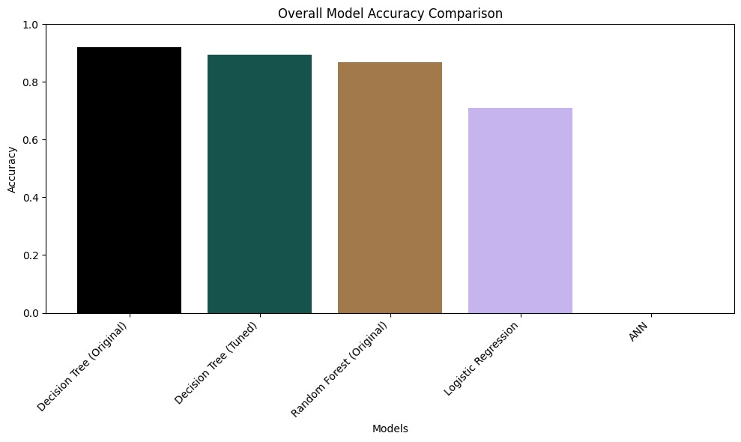

Precision and Recall Comparison Chart
Figure 9.2 presents the precision and recall for each model side by side. The Decision Tree (Original) shows the highest and most balanced values. The ANN model exhibits the widest gap between precision and recall, indicating inconsistent per-class performance.
Figure 9.2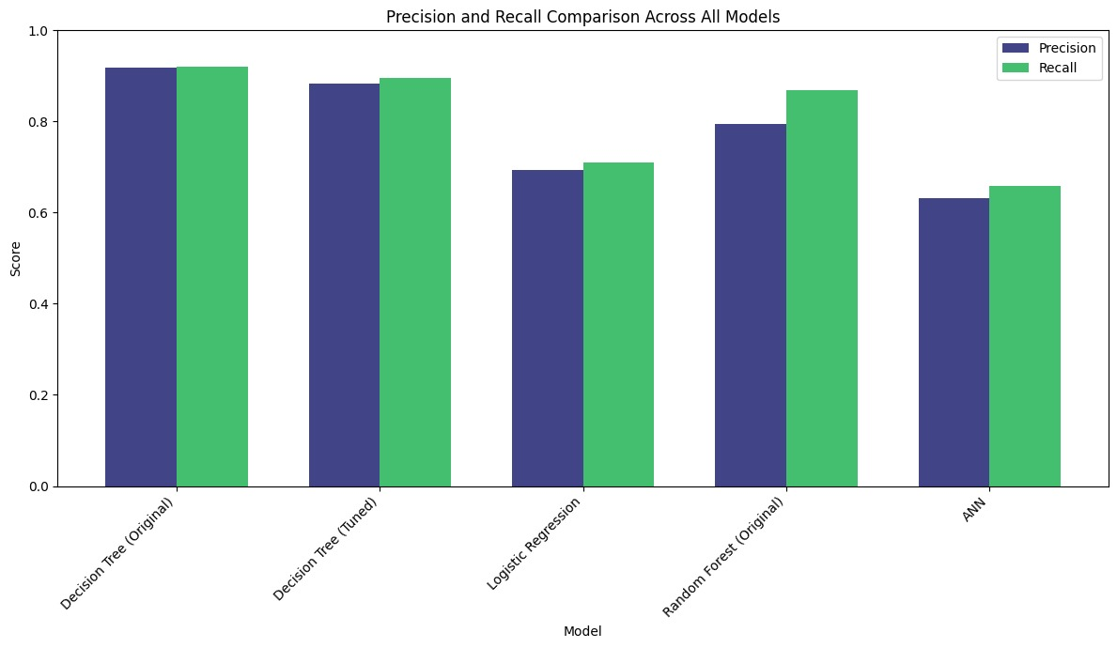

CHAPTER 10: VISUALIZATION

Decision Tree Visualization (Tuned Model)
The Decision Tree (Tuned) model was visualized using Scikit-learn's plot_tree function with filled=True to color-code each leaf node by class. Figure 10.1 shows the actual Decision Tree decision logic, branching on features such as Nitrogen, Potassium, Phosphorus, and Temperature to arrive at the recommended fertilizer class.
Figure 10.1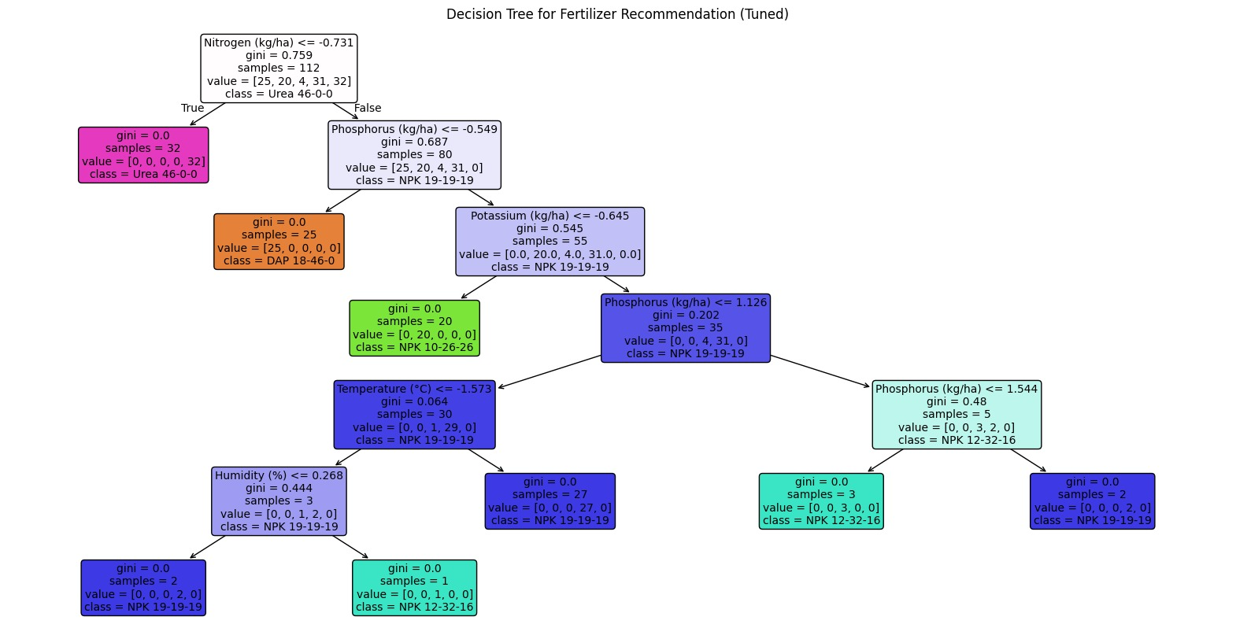

Confusion Matrix — Decision Tree (Original)
The confusion matrix for the best-performing model shows true positive predictions along the diagonal. The model achieves near-perfect classification for most fertilizer classes, with minor misclassifications between classes 2 and 3.
Figure 10.2: Confusion Matrix — Decision Tree (Original)
 | Predicted Cls 0 | Predicted Cls 1 | Predicted Cls 2 | Predicted Cls 3 | Predicted Cls 4
Actual Cls 0 | 11 | 0 | 0 | 0 | 0
Actual Cls 1 | 0 | 4 | 0 | 0 | 0
Actual Cls 2 | 0 | 0 | 2 | 2 | 0
Actual Cls 3 | 0 | 0 | 1 | 8 | 0
Actual Cls 4 | 0 | 0 | 0 | 0 | 10

CHAPTER 11: LIMITATIONS
While the Fertilizer Recommendation System demonstrates promising accuracy, several limitations must be acknowledged. First, the dataset used is sourced from Kaggle and may not fully represent the diversity of real-world soil conditions, regional climate variations, or farming practices across different geographies. The relatively small test set size may also affect the statistical reliability of evaluation metrics.

Second, the ANN model (MLPClassifier) failed to converge within the set limit of 1,000 iterations, as indicated by the ConvergenceWarning in the notebook output. This suggests that the neural network may benefit from a larger dataset, deeper architecture, or an extended training regime.

Third, the system currently does not account for dynamic, real-time data inputs such as live IoT sensor readings, satellite-based soil imagery, or time-series weather forecasts. All features are assumed to be static snapshots.

Fourth, the label encoding approach treats categorical variables as ordinal, which may introduce unintended relationships between encoded classes. One-Hot Encoding or Embedding layers would be more suitable for deep learning models. Finally, the system predicts from a fixed set of five fertilizer classes and cannot recommend custom nutrient blends or dosage amounts.

CHAPTER 12: CONCLUSION
This project successfully developed and evaluated a machine learning-based Fertilizer Recommendation System that predicts the optimal fertilizer for given soil and crop conditions. Through the comparative evaluation of five model configurations, it was established that the original Decision Tree Classifier achieved the highest test accuracy of 92.11%, making it the best-performing model for this dataset and task.

The project demonstrated the critical importance of preprocessing steps such as Label Encoding and StandardScaler normalization in ensuring fair and effective model training. The use of GridSearchCV for hyperparameter tuning further validated the robustness of the Decision Tree approach, yielding a cross-validation accuracy of 98.20%. The visualization of the Decision Tree structure provides interpretability valuable in agricultural advisory applications.

From a practical perspective, the system offers a scalable, data-driven solution for precision agriculture. By replacing intuition-based fertilizer application with an evidence-based recommendation engine, the system has the potential to reduce agricultural input costs, minimize environmental damage from over-fertilization, and contribute to higher and more consistent crop yields.

Future work should focus on expanding the dataset with diverse geographical and seasonal records, exploring advanced deep learning architectures, integrating IoT and satellite data for real-time input, and deploying the system as a mobile or web-based application accessible to farmers. Incorporating explainability techniques such as SHAP will also enhance user trust and adoption.

REFERENCES
1. Sharma, R., et al. (2024). "Crop-Specific Fertilizer Prediction Using Random Forest and Gradient Boosting." IEEE Access, 12, 45231–45244.
2. Patel, A., & Kumar, V. (2024). "Deep Learning-Based Soil Nutrient Analysis for Precision Fertilizer Management." Journal of Agricultural Informatics, 15(2), 78–93.
3. Nguyen, T., et al. (2024). "A Comparative Study of Machine Learning Classifiers for Fertilizer Recommendation in Rice Cultivation." Computers and Electronics in Agriculture, 218, 108725.
4. Ramesh, K., & Priya, S. (2025). "Explainable AI for Smart Fertilizer Recommendations: Integrating SHAP with Tree-Based Models." Precision Agriculture Journal, 26(1), 112–130.
5. Zhang, W., et al. (2025). "Hybrid CNN-LSTM Model for Fertilizer Demand Forecasting in Smart Greenhouses." Agricultural Systems, 220, 103998.
6. Bose, A. (2024). "Applying Transfer Learning for Fertilizer Prediction in Data-Sparse Regions." International Journal of Remote Sensing, 45(8), 2930–2948.
7. Kulkarni, M., & Desai, P. (2024). "Multi-Label Fertilizer Recommendation Using Gradient Boosting Trees on Kaggle Benchmark Data." Applied Soft Computing, 158, 111512.
8. Fernandes, L., et al. (2025). "IoT-Integrated Machine Learning System for Real-Time Fertilizer Advisory in Sugarcane Fields." Smart Agriculture Technology, 9, 100385.
9. Verma, D., & Singh, H. (2024). "Decision Tree Hyperparameter Optimization Using Bayesian Search for Fertilizer Classification." Expert Systems with Applications, 238, 122012.
10. Huang, Y., et al. (2025). "Attention-Based Transformer Networks for Crop Nutrient Recommendation." npj Sustainable Agriculture, 3, 18.
11. Pedregosa, F., et al. (2011). "Scikit-learn: Machine Learning in Python." Journal of Machine Learning Research, 12, 2825–2830.
12. Breiman, L. (2001). "Random Forests." Machine Learning, 45(1), 5–32.
13. Quinlan, J.R. (1986). "Induction of Decision Trees." Machine Learning, 1(1), 81–106.

